Time 1.30 Hours (6 Routers)

Use the following diagram to configure all routers. Each network will be consisted of 20 host IP addresses. Giving 2 class C which are 192.168.10.0/24 and 192.168.11.0/24. (Any Routing protocol will be fine here)

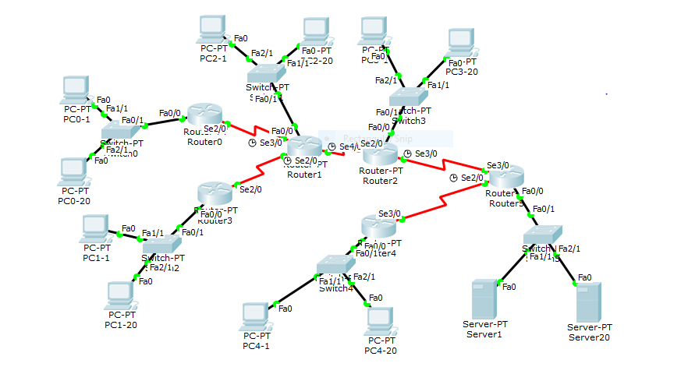

Score
1. All PCs in the diagram can ping each other 20 Points

2. All PC in the diagram can ping any router 10 Points

3. Time Max 20 Points
      - Within 20 Minutes 20 Points
      - Within 30 Minutes 15 Points
      - Within 60 Minutes 10 Points
      - Within 90 Minutes 5 Points
      - After 90 Minutes 0 Points
      - If you not finish the Lab by 90 Minutes, email me the packet tracer file at evonergy@gmail.com, by 1st Dec 2017. Use this format – [LabExam2017-YouID.pkt]

